**Q1.Create a new HDFS file structure data/dev/analysis in the HDFS home directory. Copy the covid-19 folder in to it**

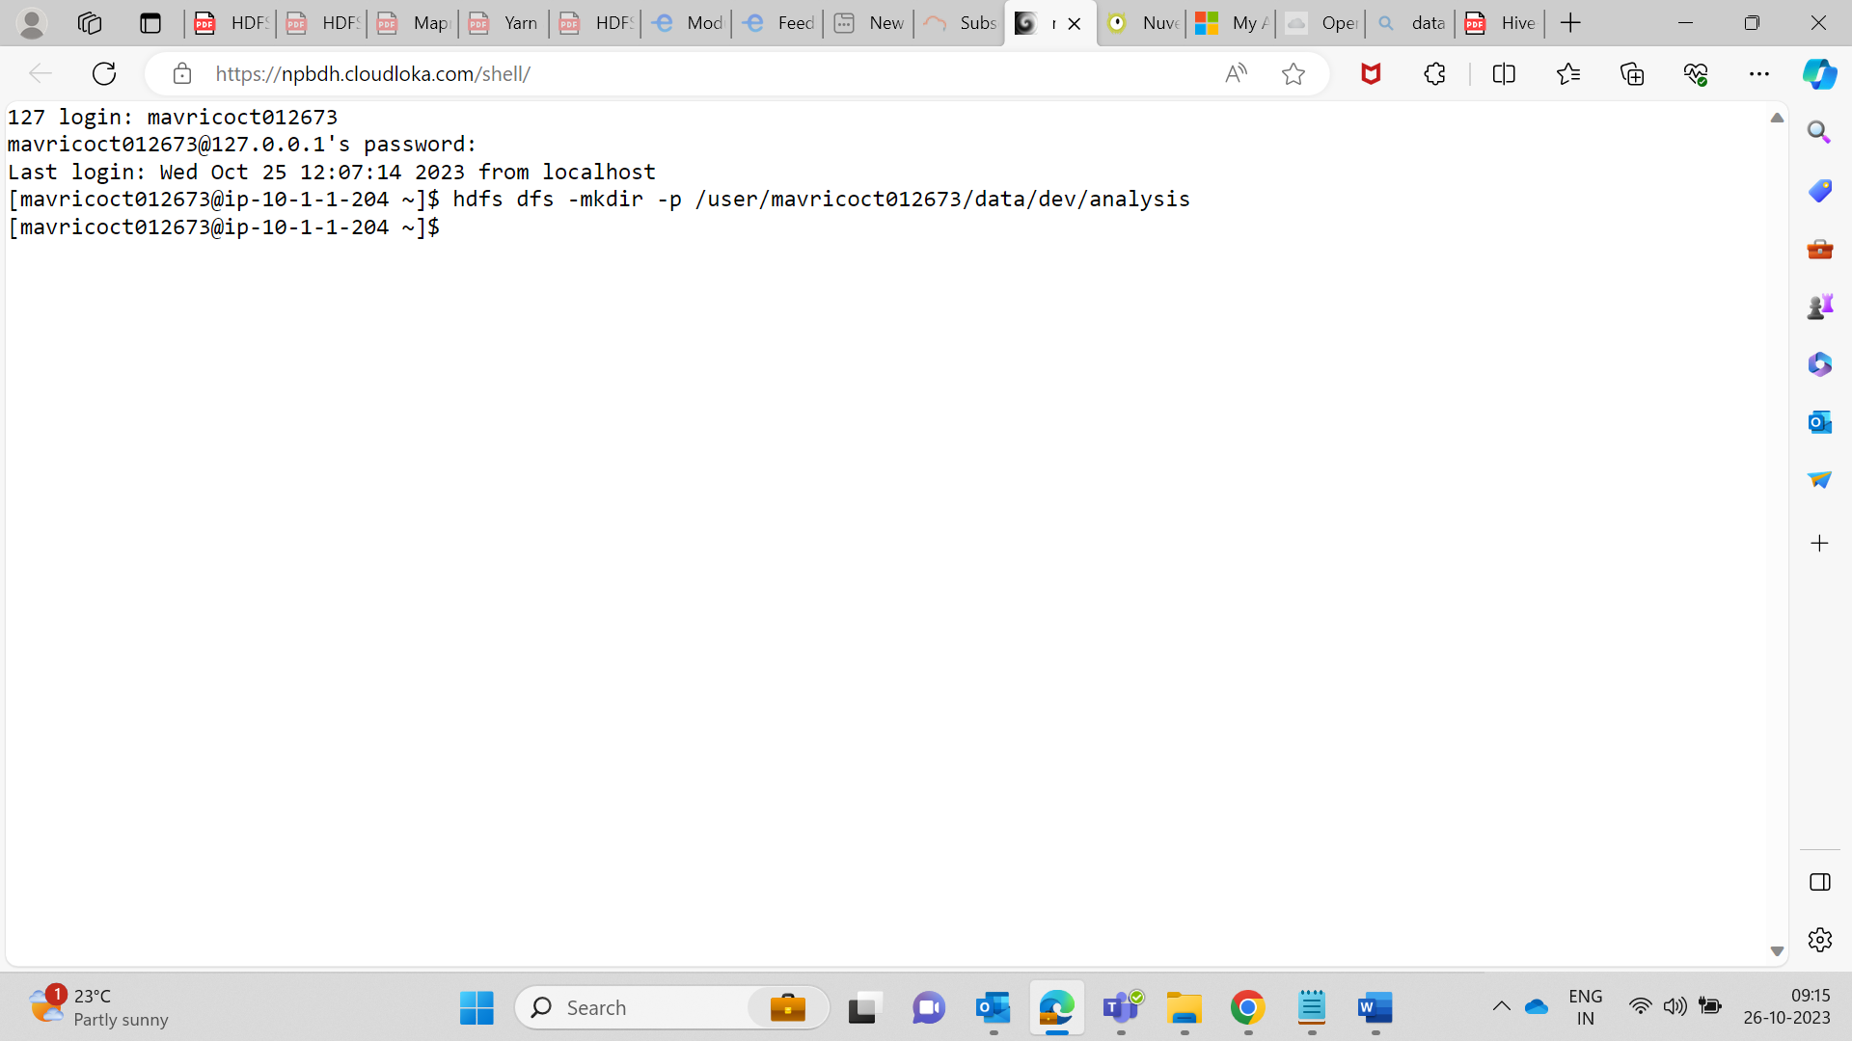

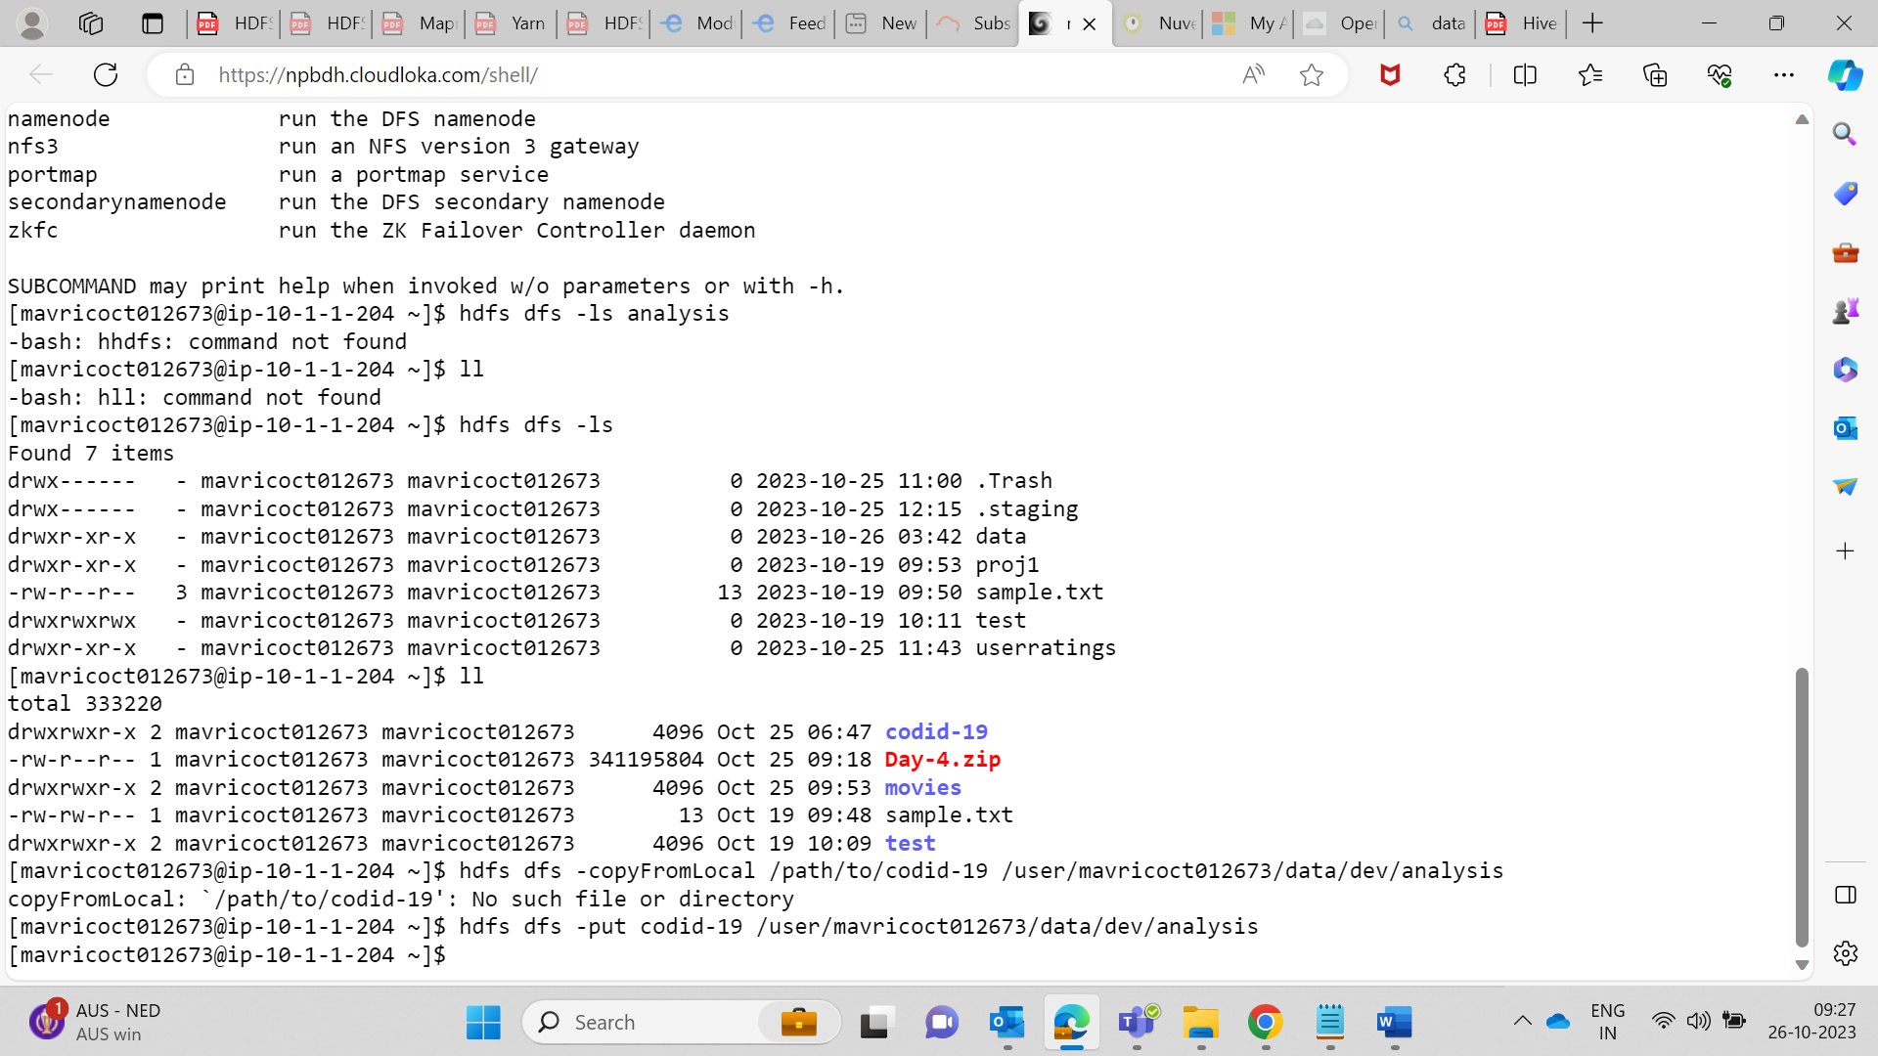

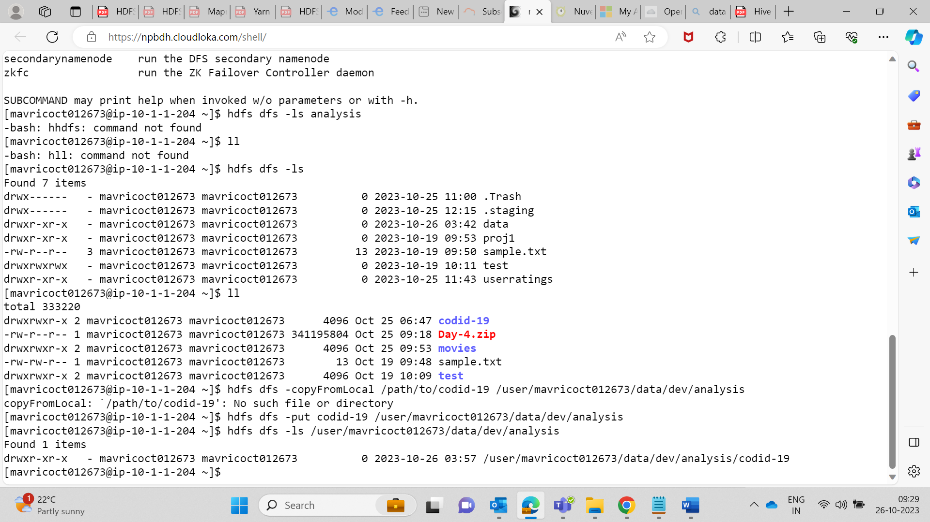

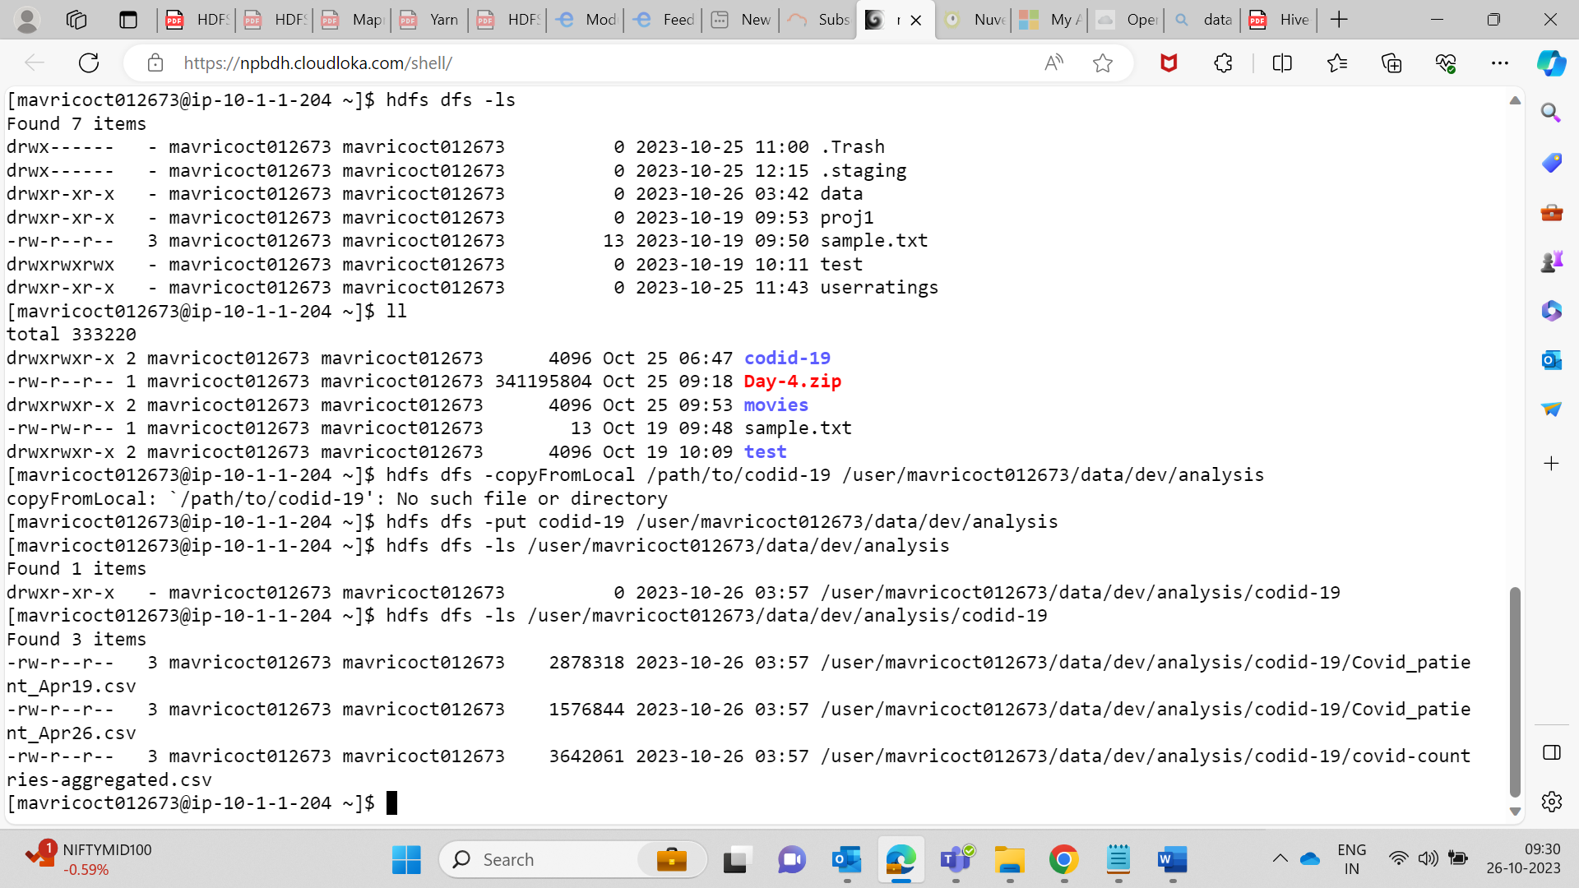

**2. . Change the permission of Covid_patient_Apr26.csv file to have only read/write/execute for the owner/ group and read/write permission for others.**

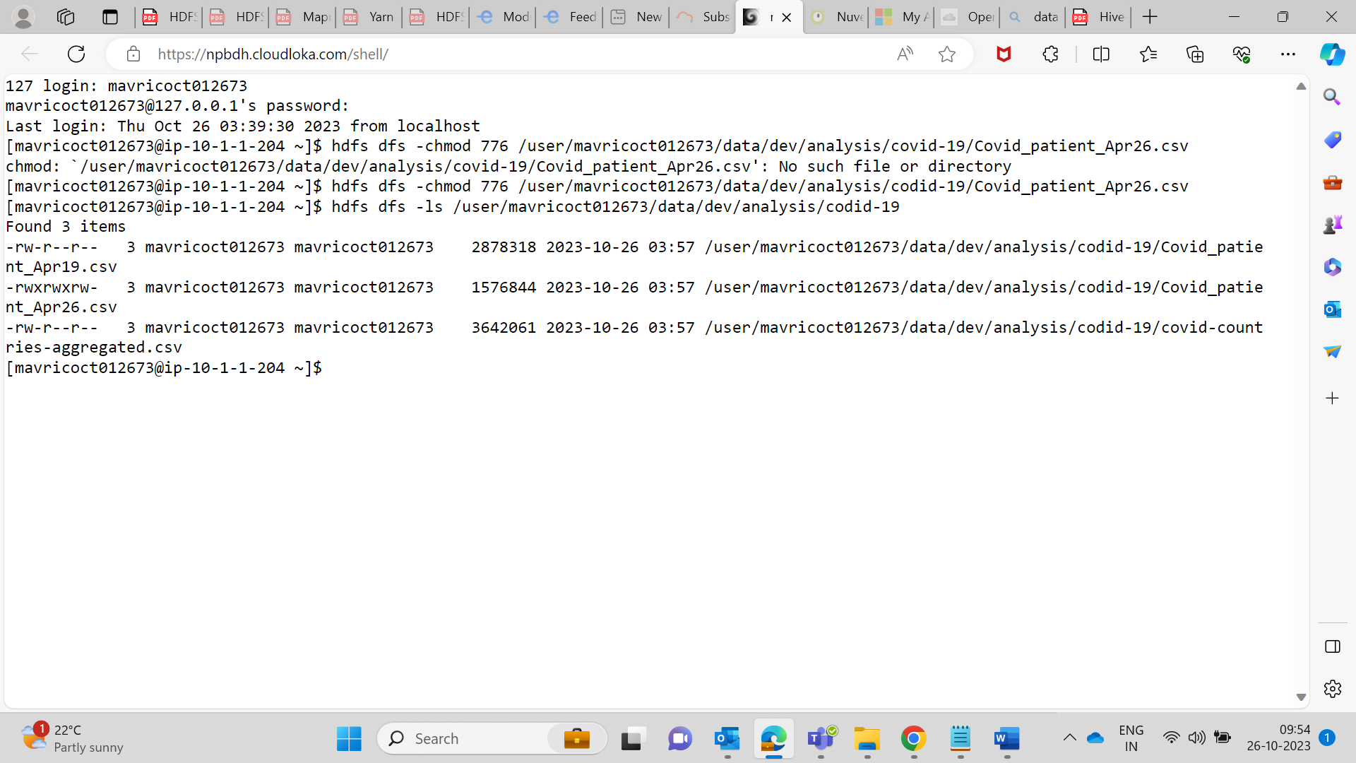

**3.Copy covid-19 folder in to another hdfs directory data/prod/analysis**

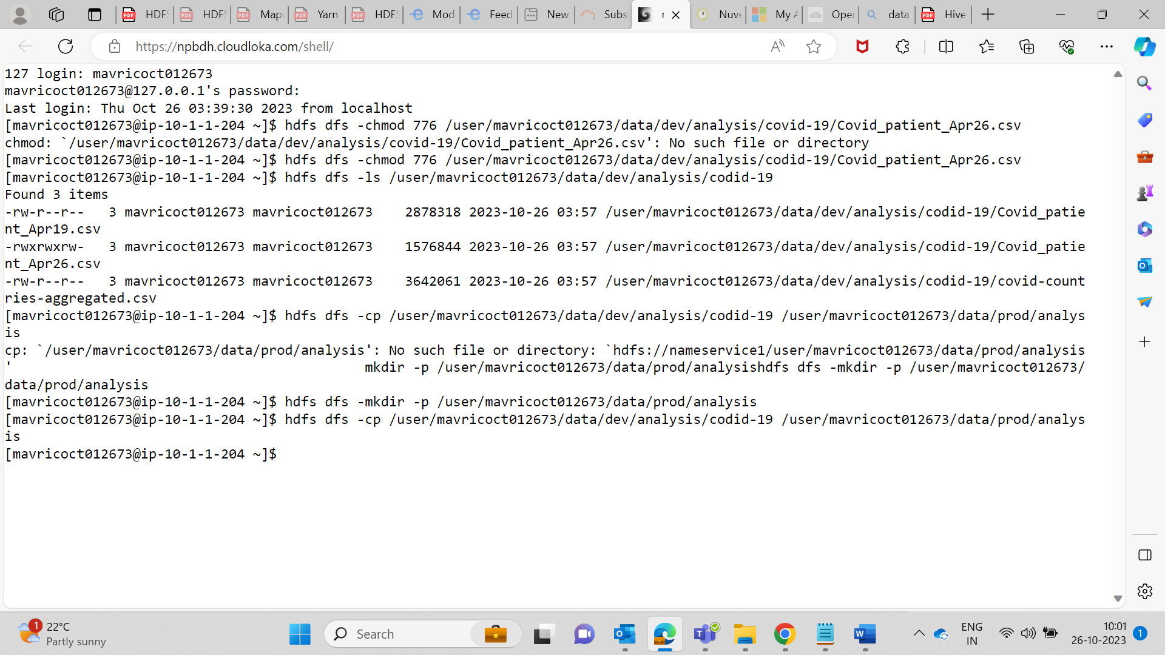

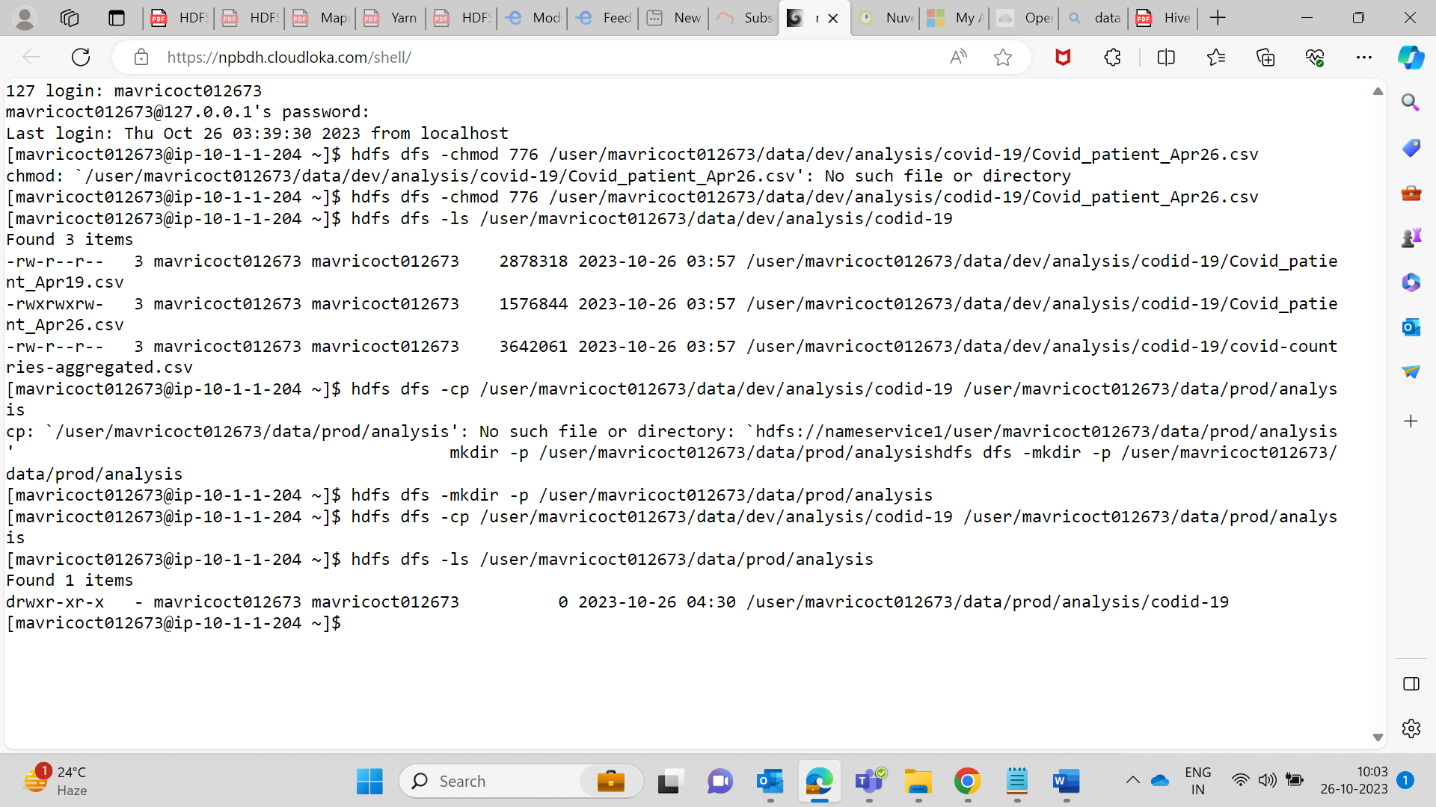

**4.Read the contents of the file Covid_patient_Apr19.csv and print the contents on the screen**

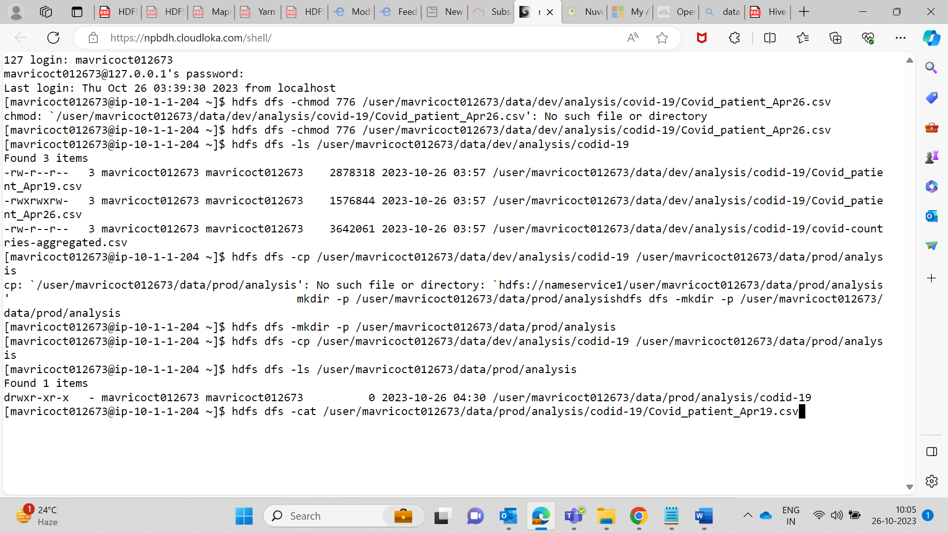

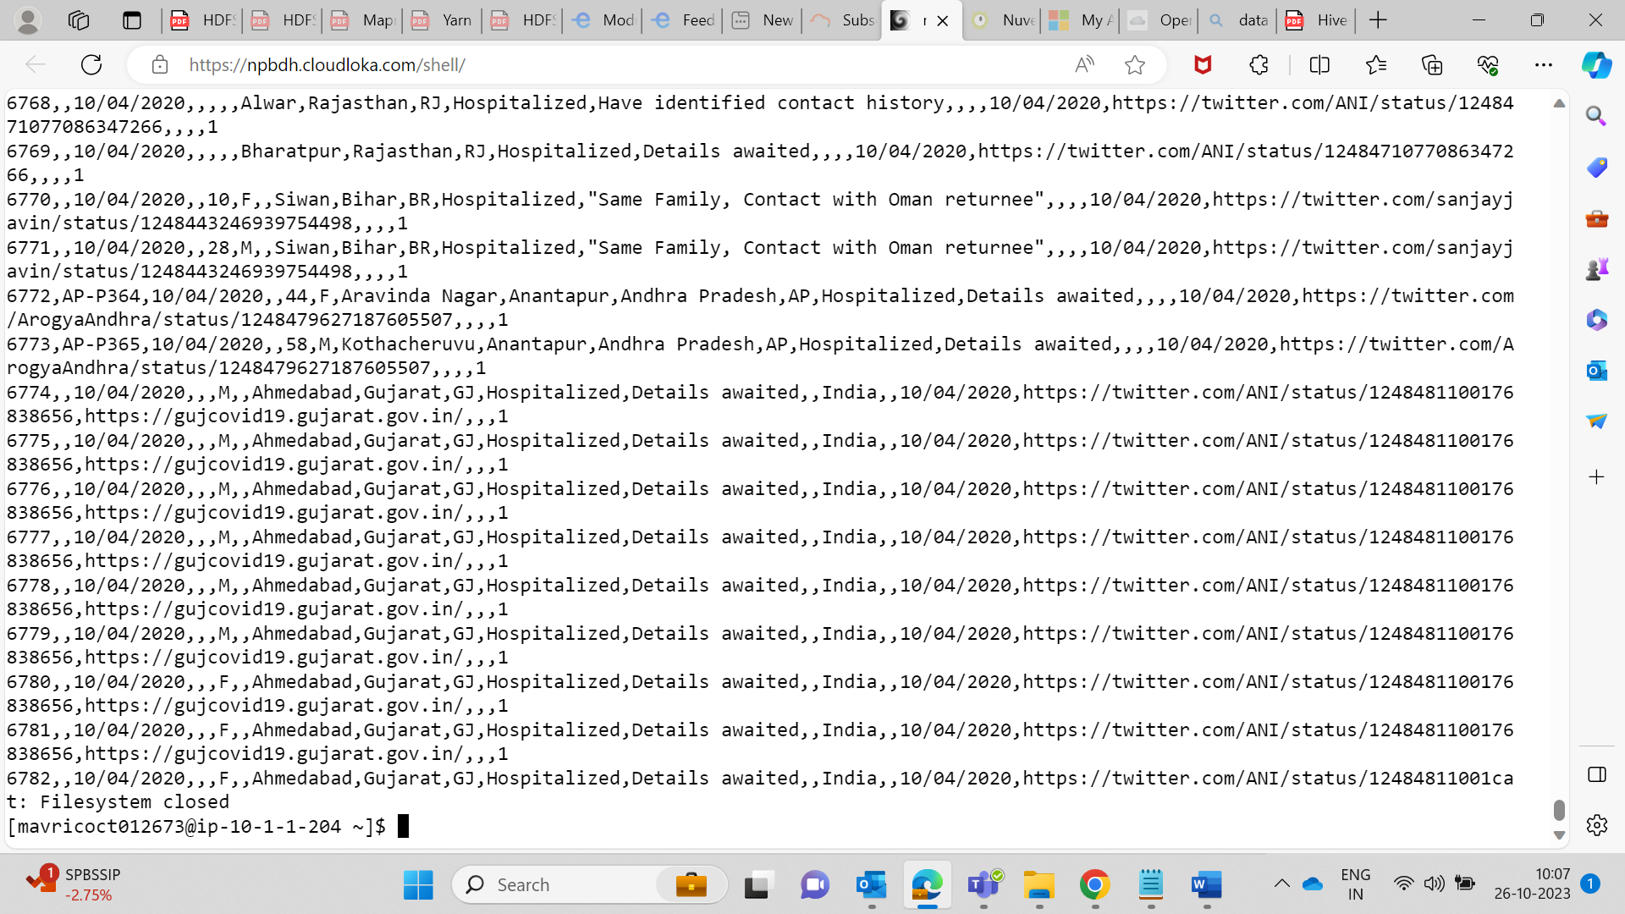

**5. Print the no of lines present in the HDFS file Covid_patient_Apr19.csv**

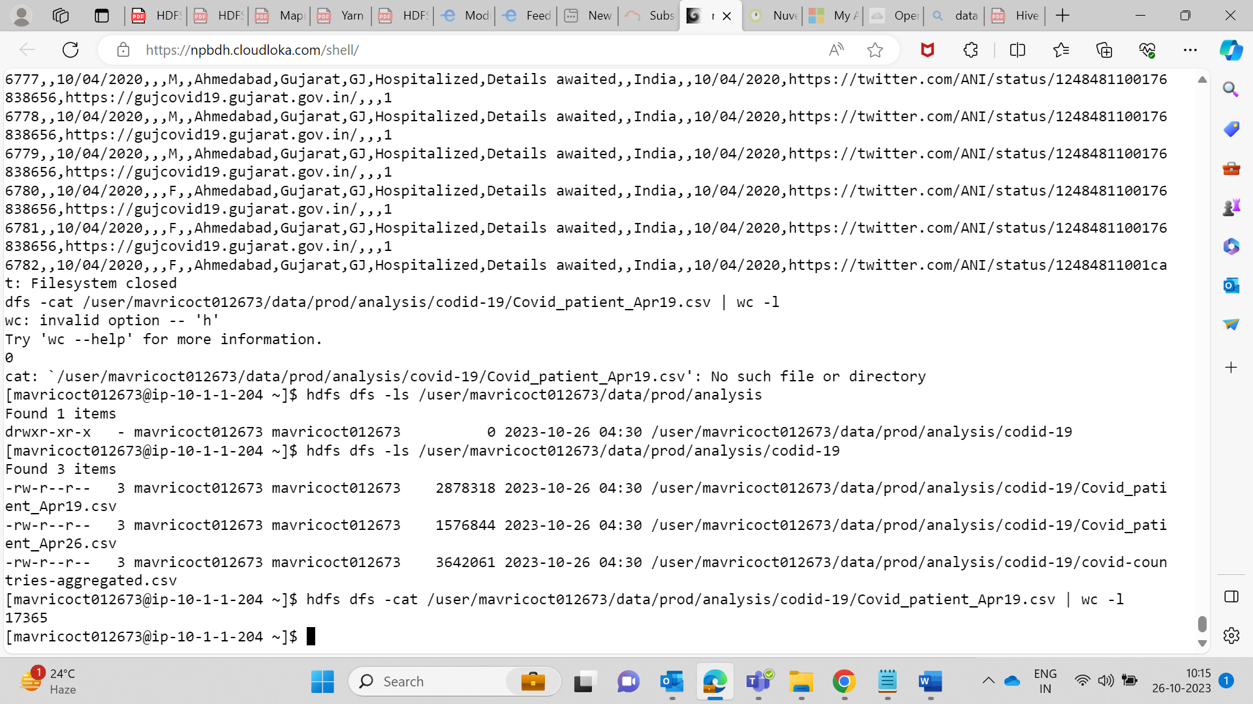

**6. Count the no of records present in the HDFS file Covid_patient_Apr19.csv for the state “UP”**

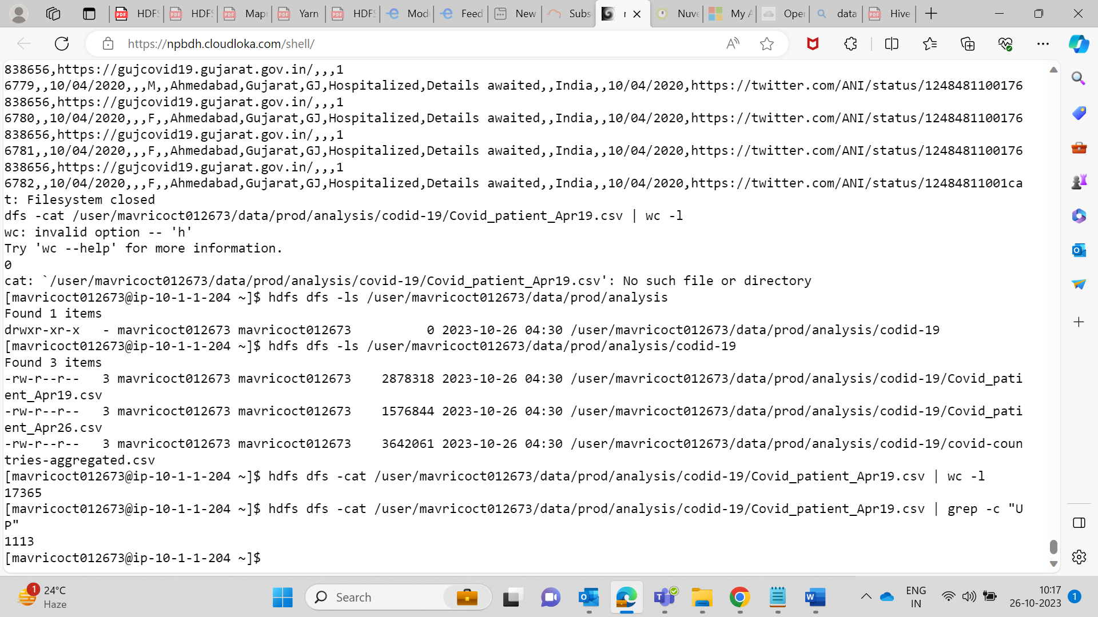

**7. Delete the file Covid_patient_Apr19.csv from the data/prod/analysis folder in HDFS**

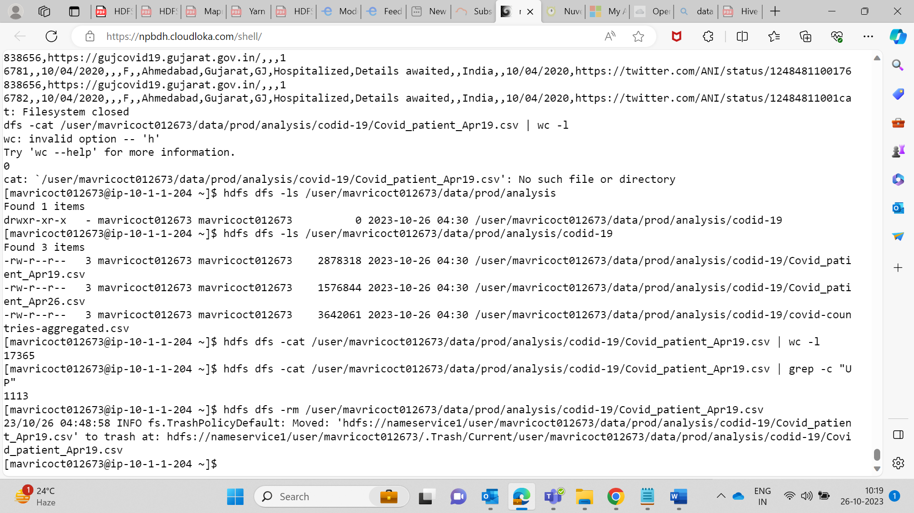

**8. Delete the covid-19 folder from both the dev and prod folders created above.**

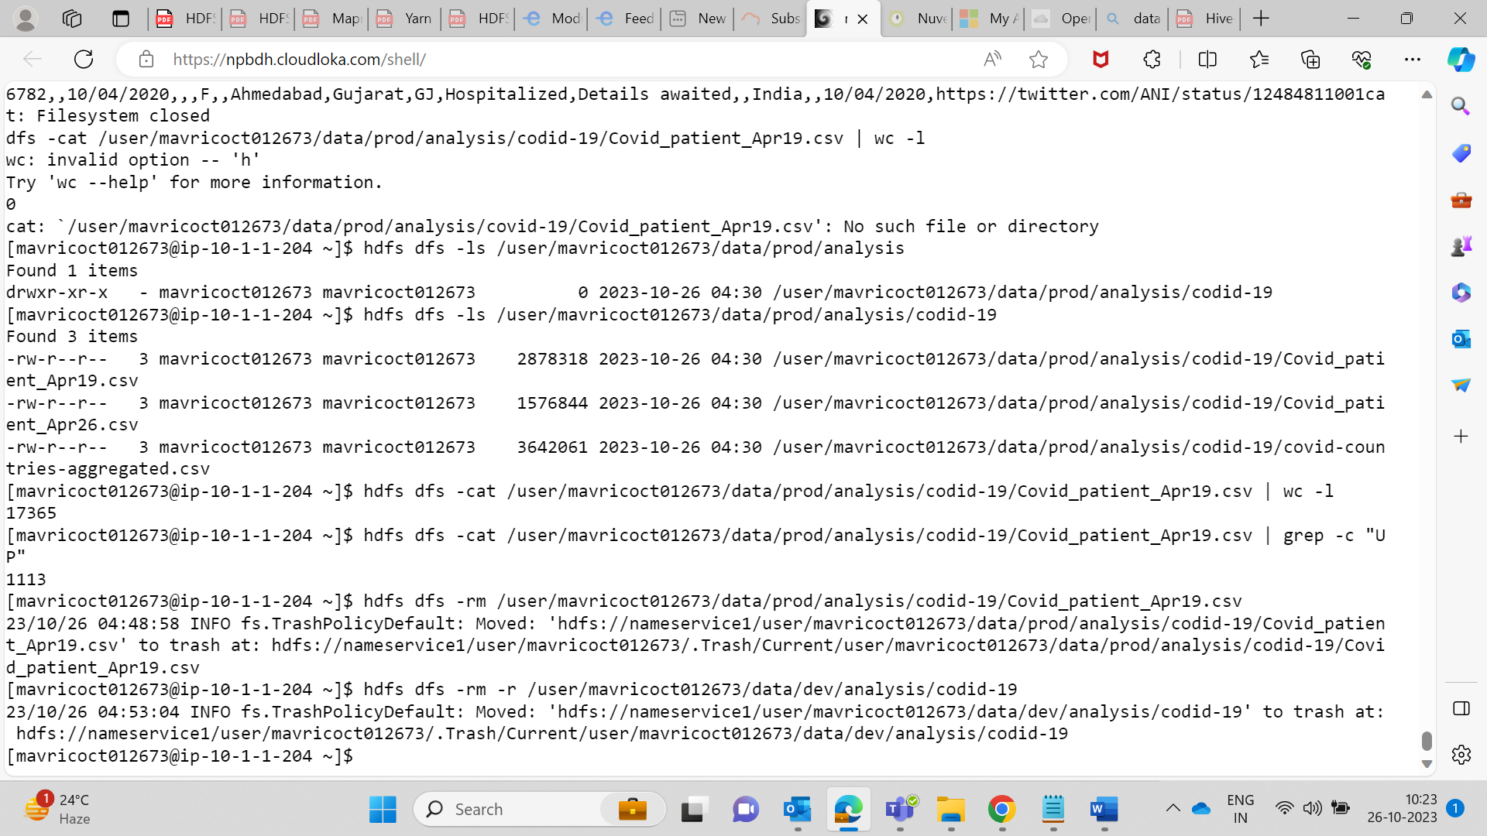

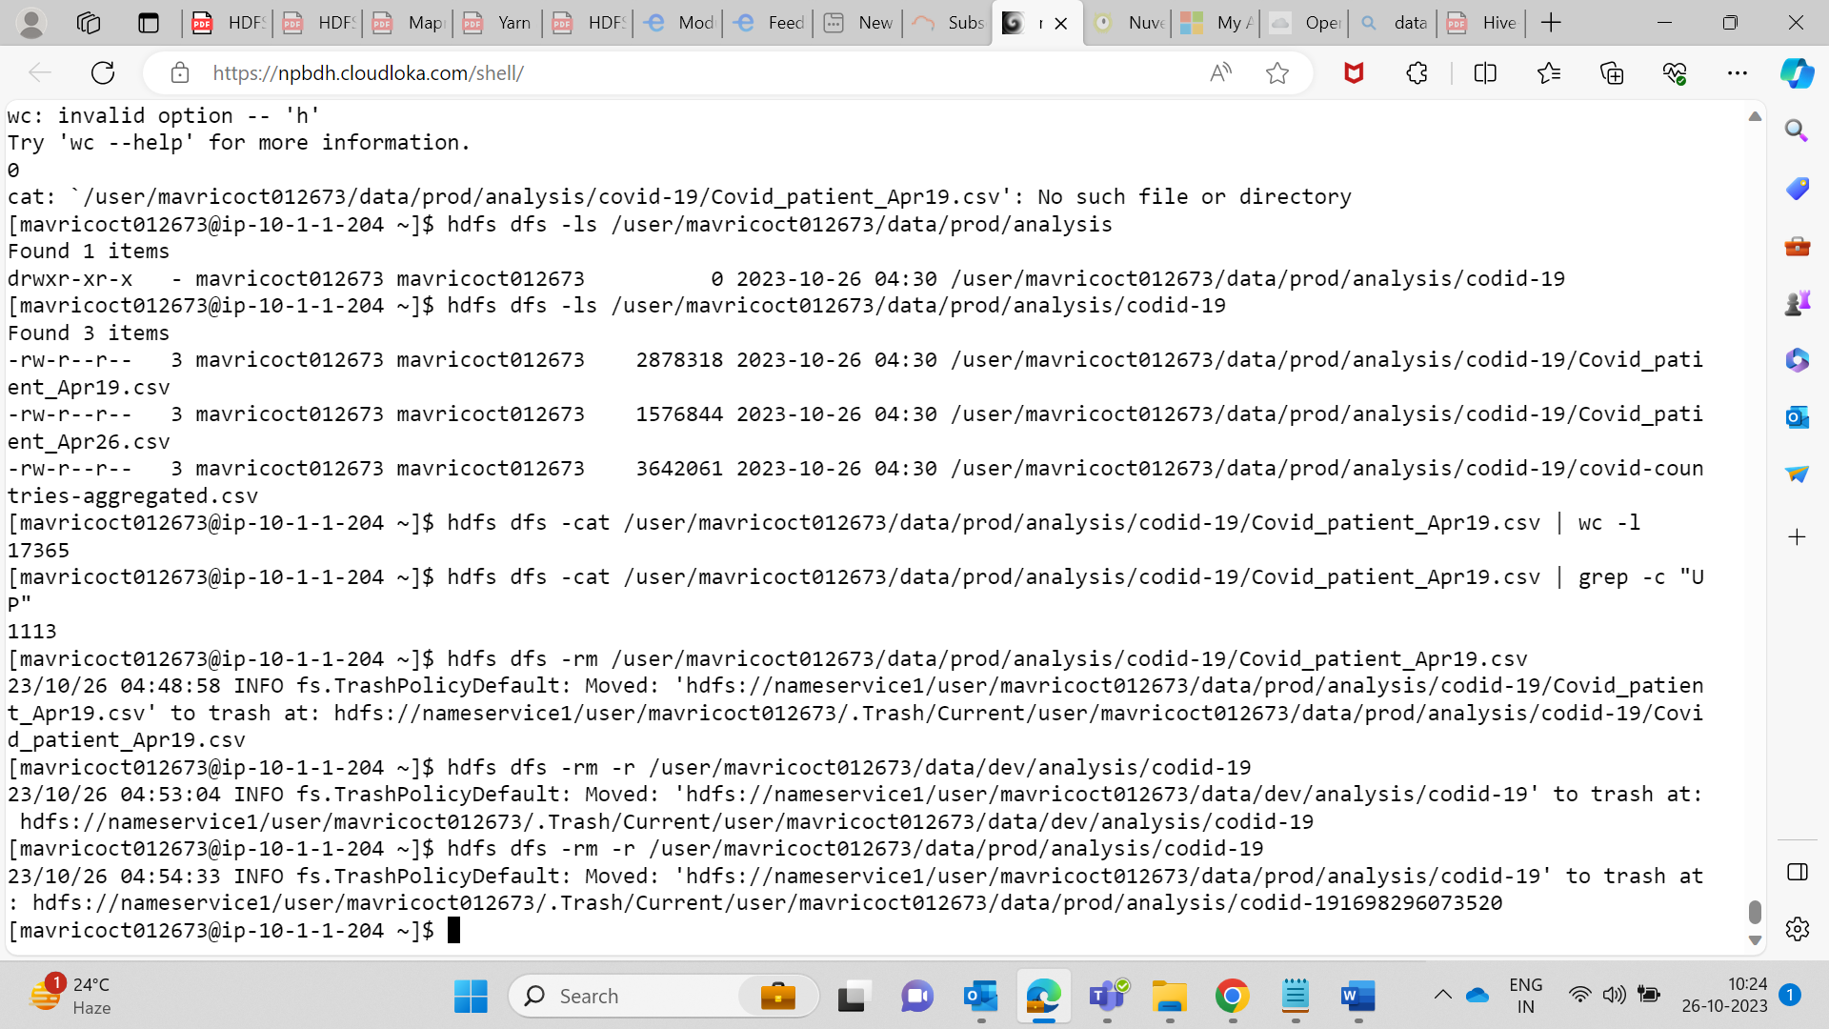

**9.Copy the tickitdb folder(in the local file system) in to HDFS home directory. How many blocks will be created for the files in this directory?**

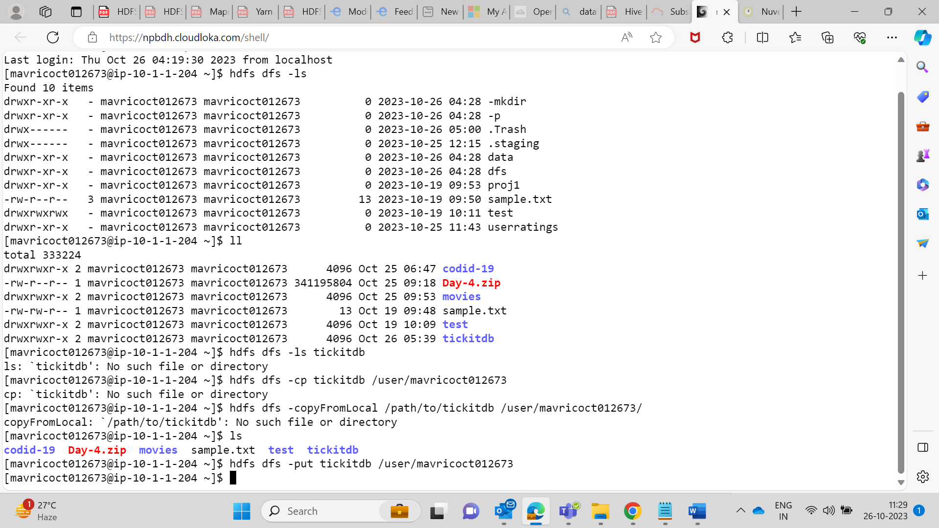

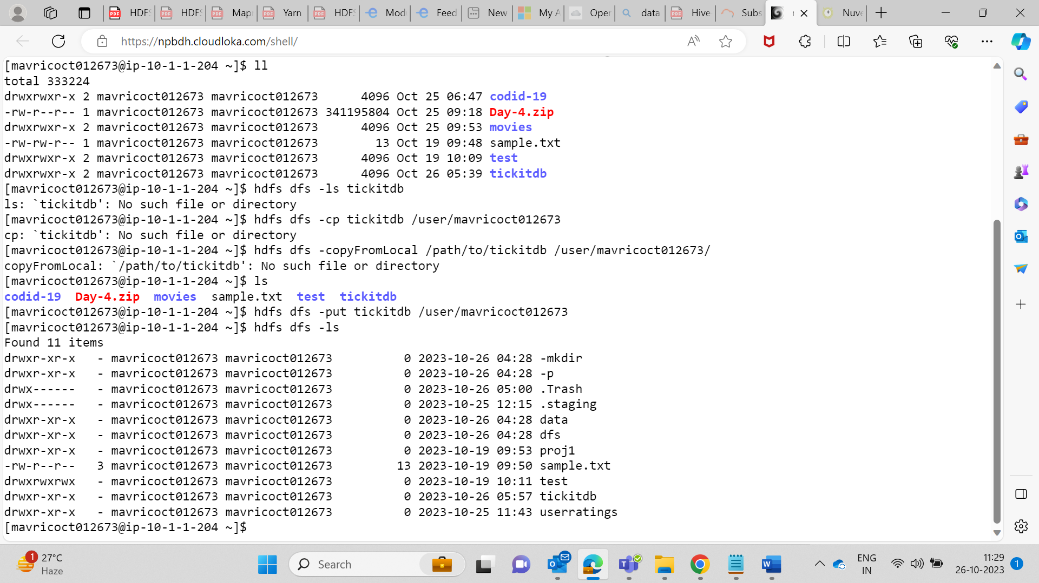

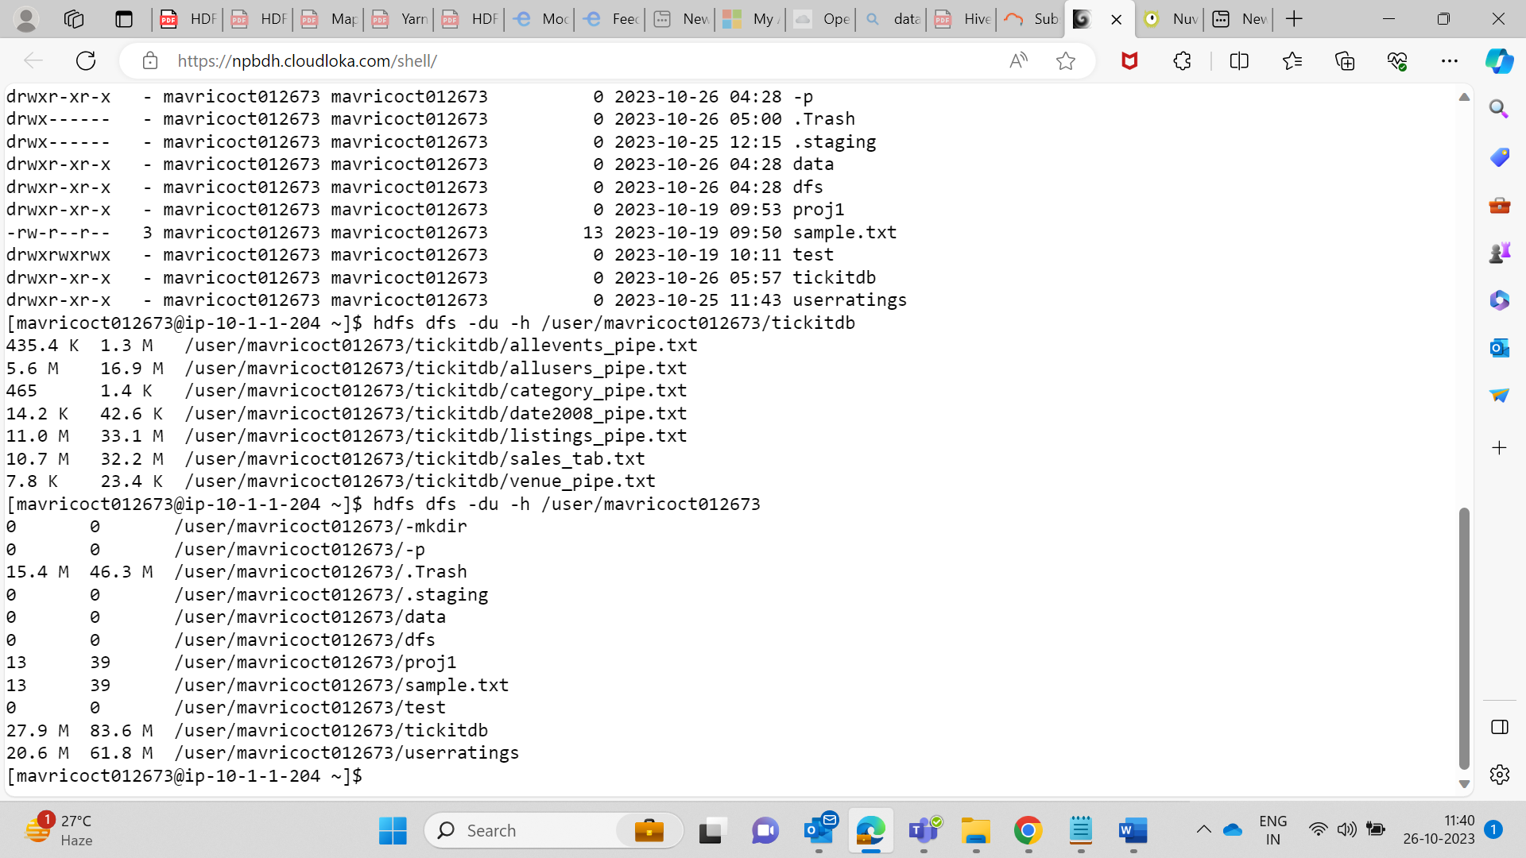  
  
as size of file is 27.3 mb so 1 block will be created.  
  
**10. . Find all the file names which has the word “pipe” in their names**

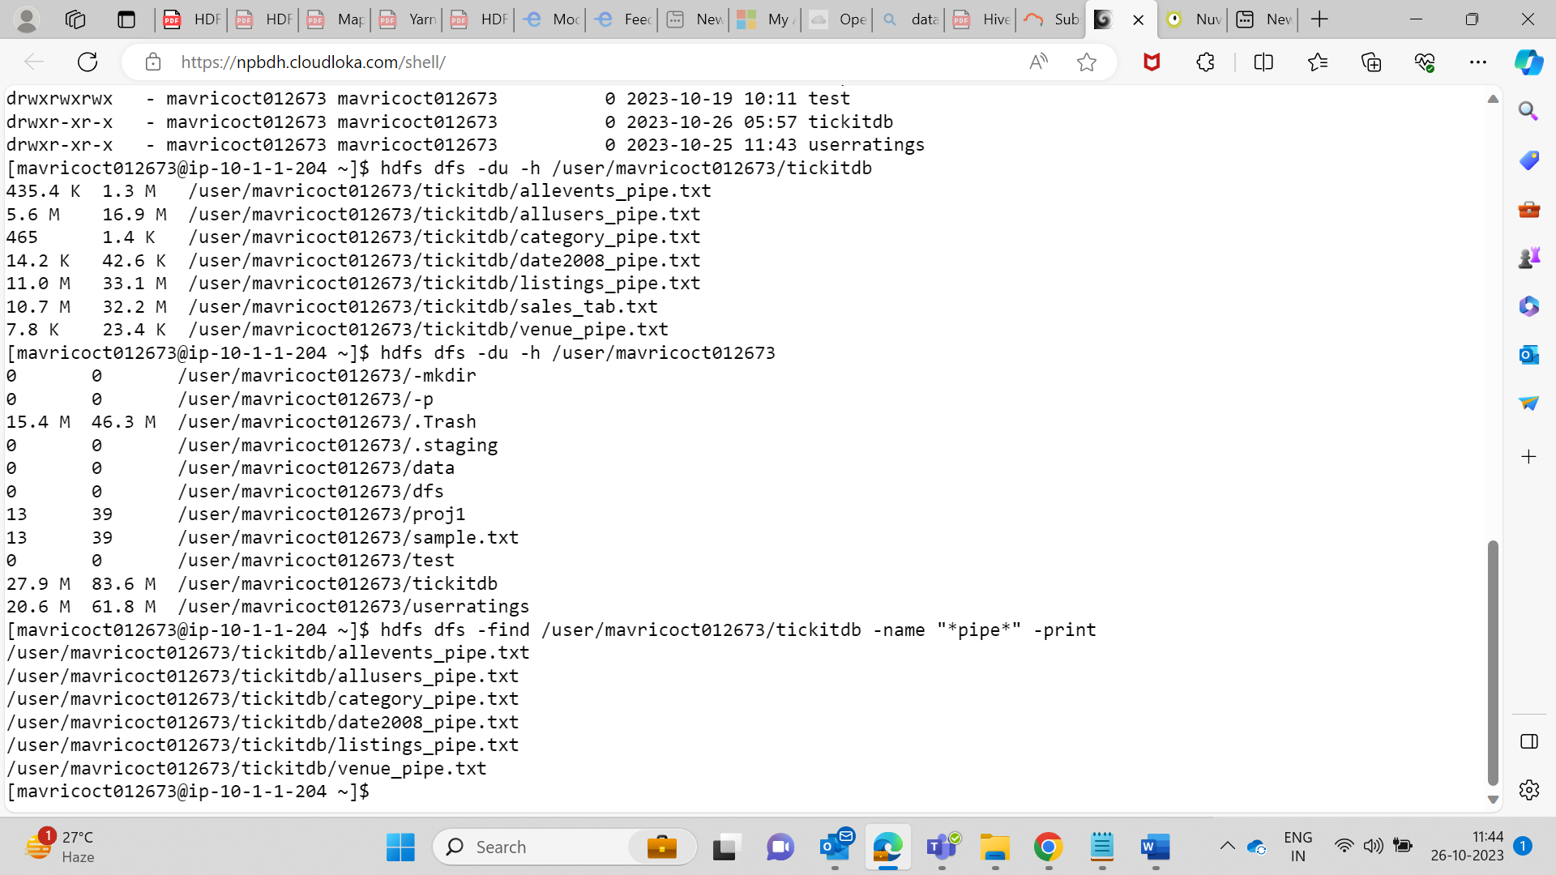

**11. Copy the h1b.csv file to hdfs home directory. How many blocks will be created for this file?**

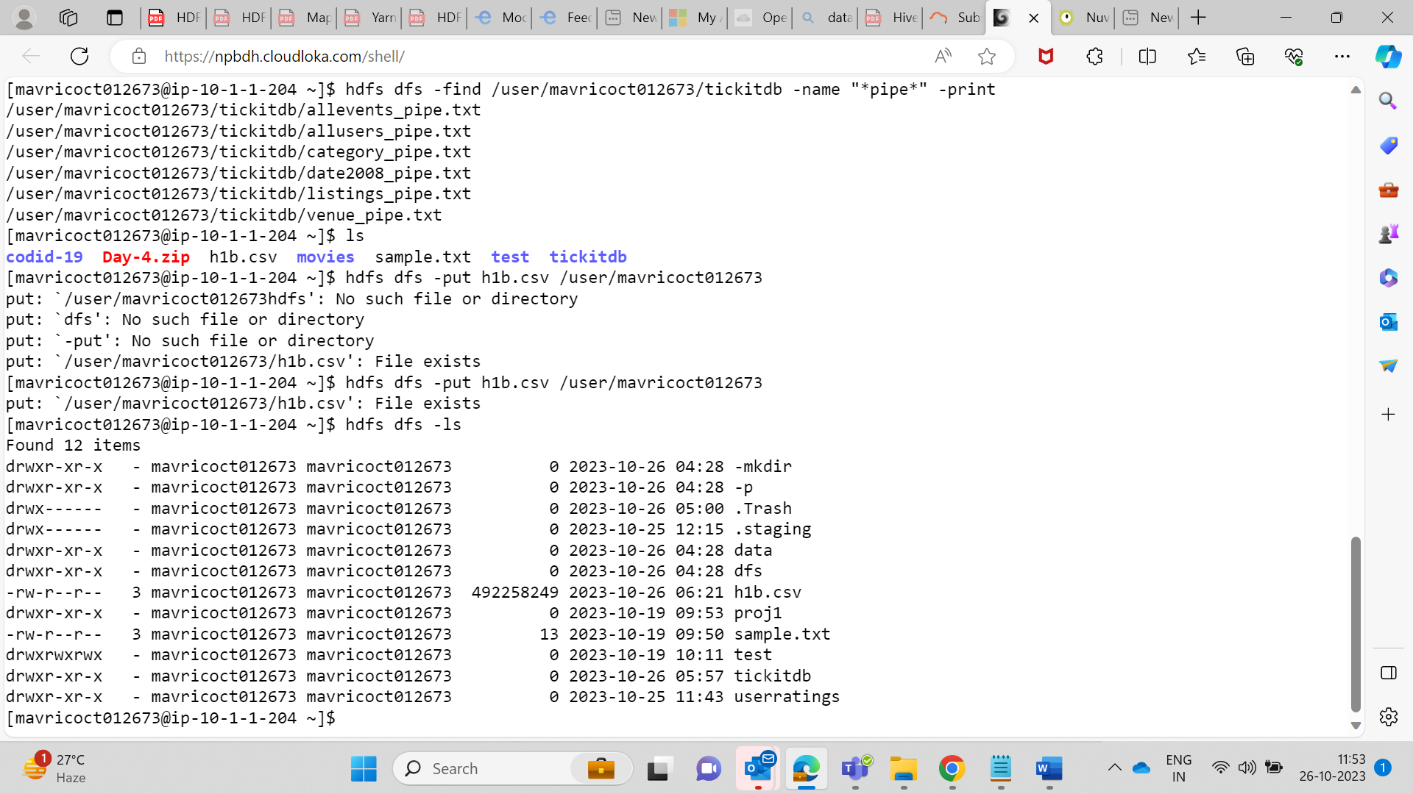

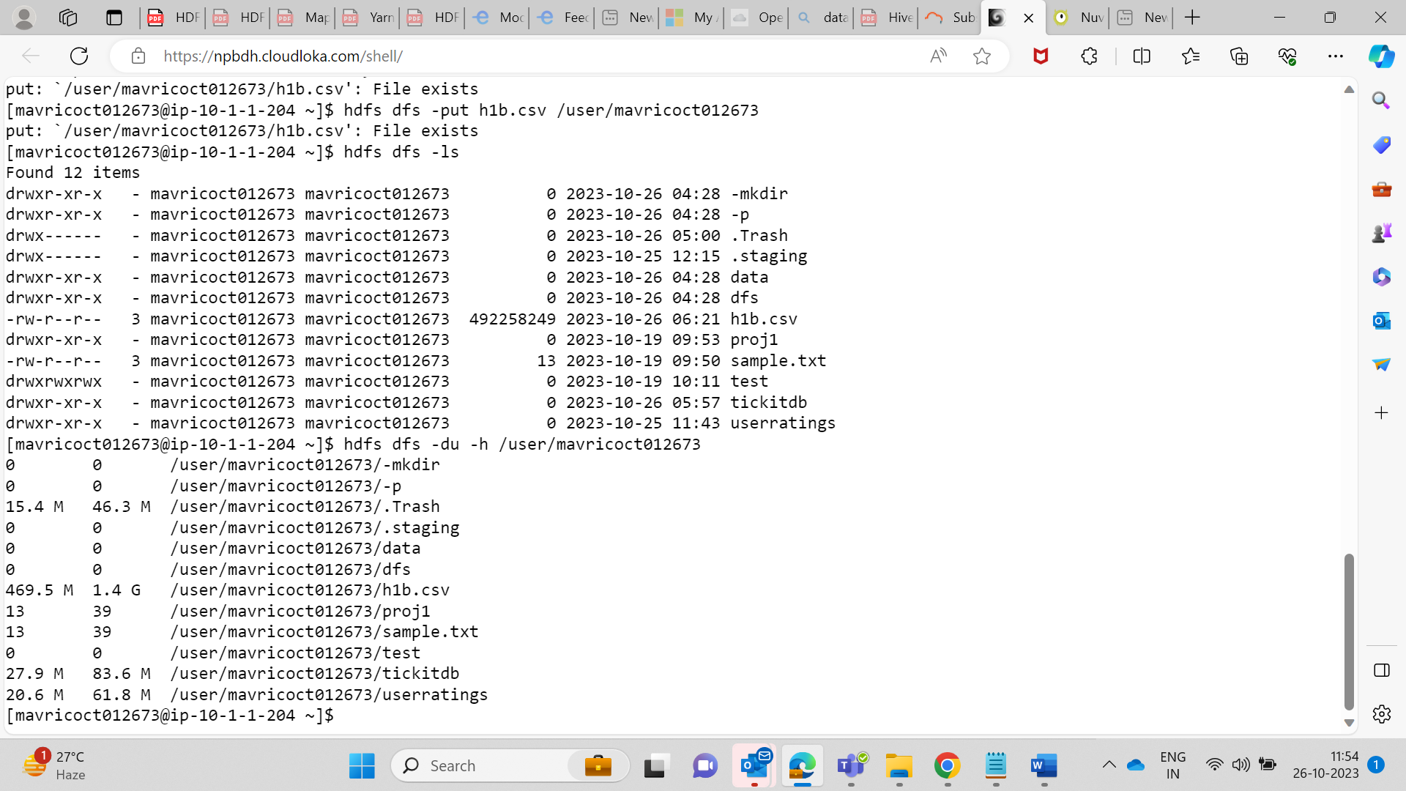

Number of Blocks = (File Size in Bytes) / (HDFS Block Size in Bytes) Number of Blocks = (469 * 1024 * 1024 bytes) / (128 * 1024 * 1024 bytes) Number of Blocks = 3.6640625 blocks

So 4 block will be created  
 **12. Move the h1b.csv file (in the HDFS) to the tickitdb folder in hdfs. How many blocks will be there for the tickitdb folder?**

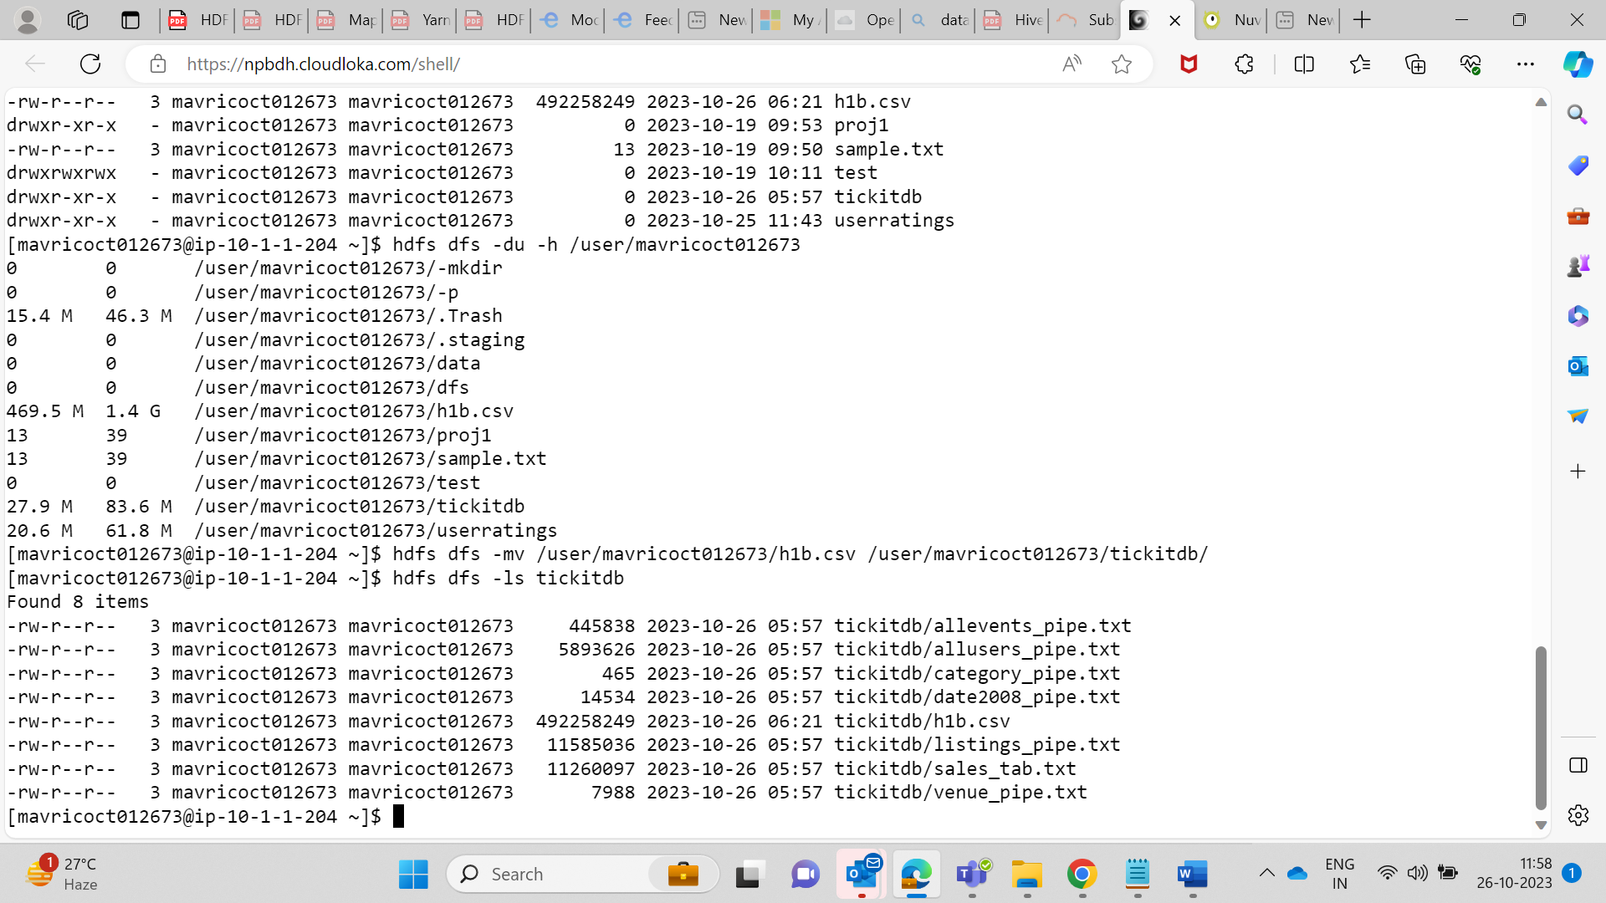

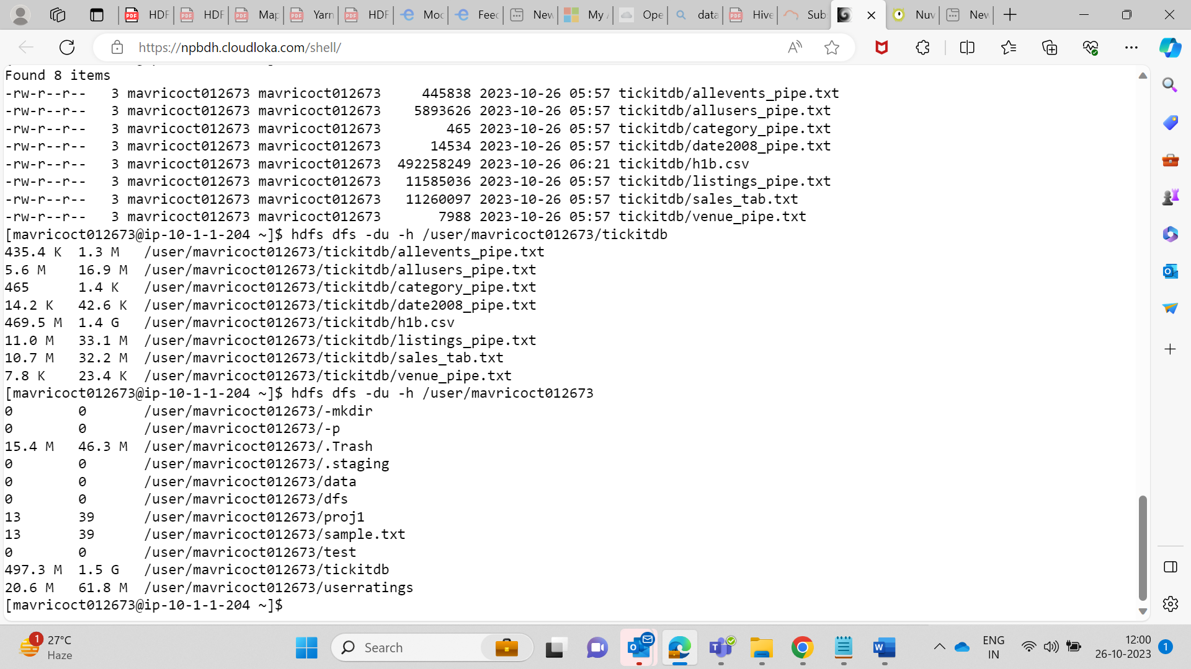

Number of Blocks = (File Size in Bytes) / (HDFS Block Size in Bytes) Number of Blocks = (497.3 * 1024 * 1024 bytes) / (128 * 1024 * 1024 bytes) Number of Blocks = 3.890625 blocks

So Data is store in 4 Blocks

**13. . Calculate the total storage space occupied by the files directory and its contents.**

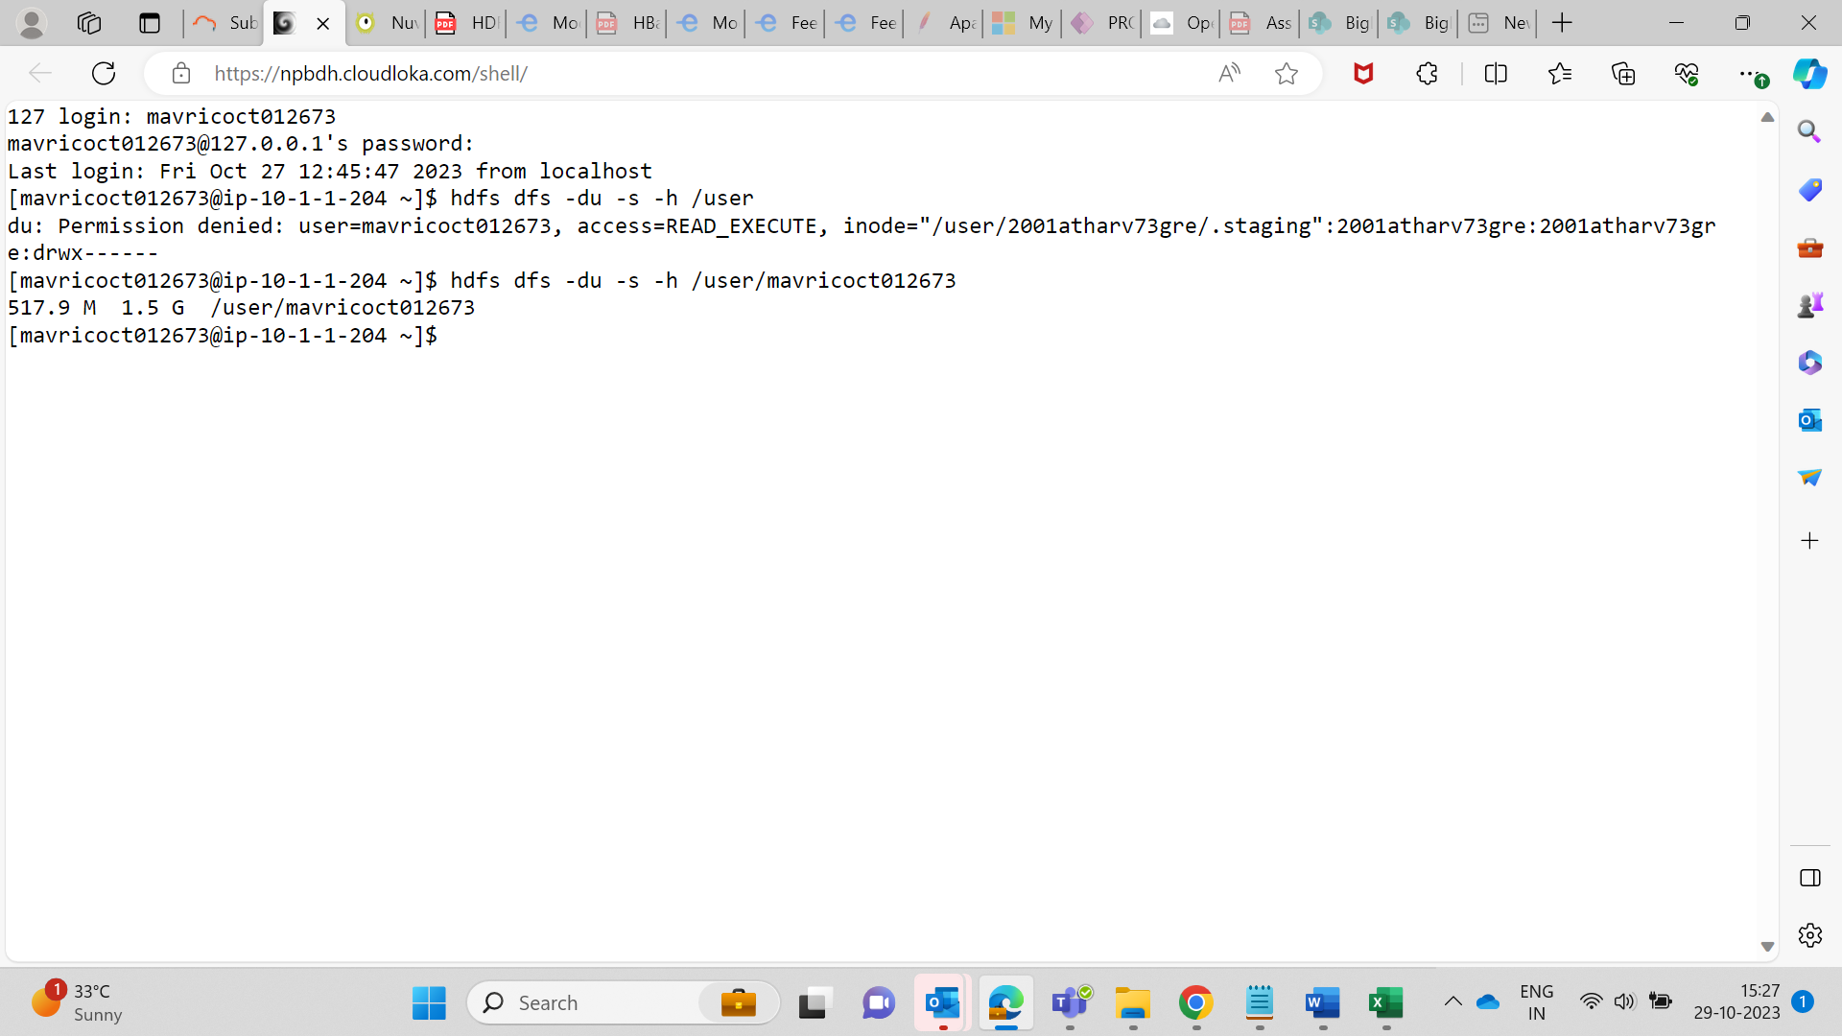

**14. Check the storage quota for the file directory.**  
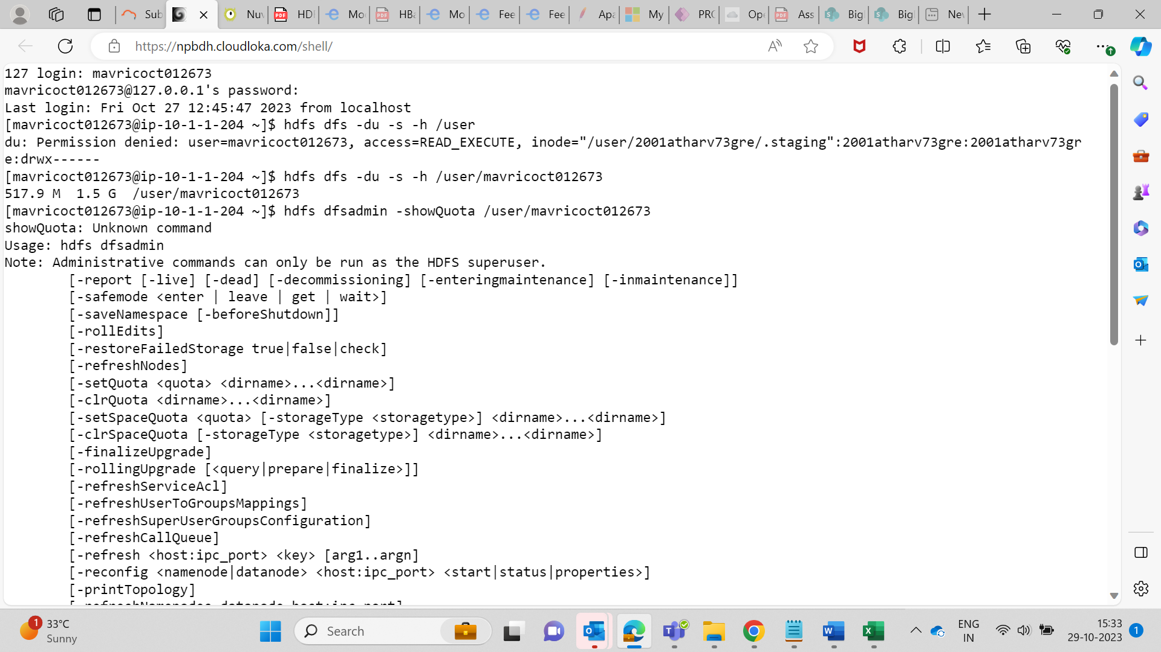

Getting error as only admin can storage Quota of files

**15. Delete a specific snapshot 'snapshot1' from the file directory.**

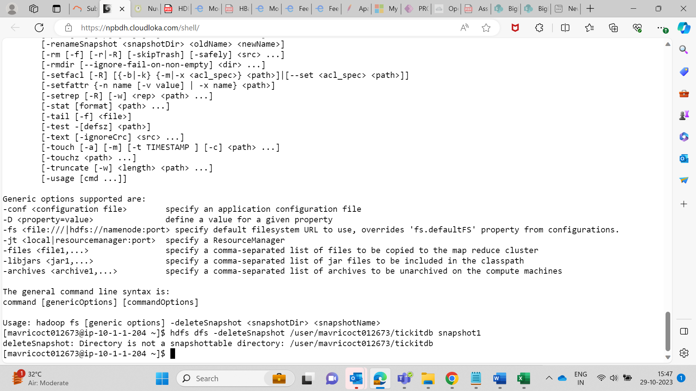

**16. Create a snapshot of the file directory in HDFS.**

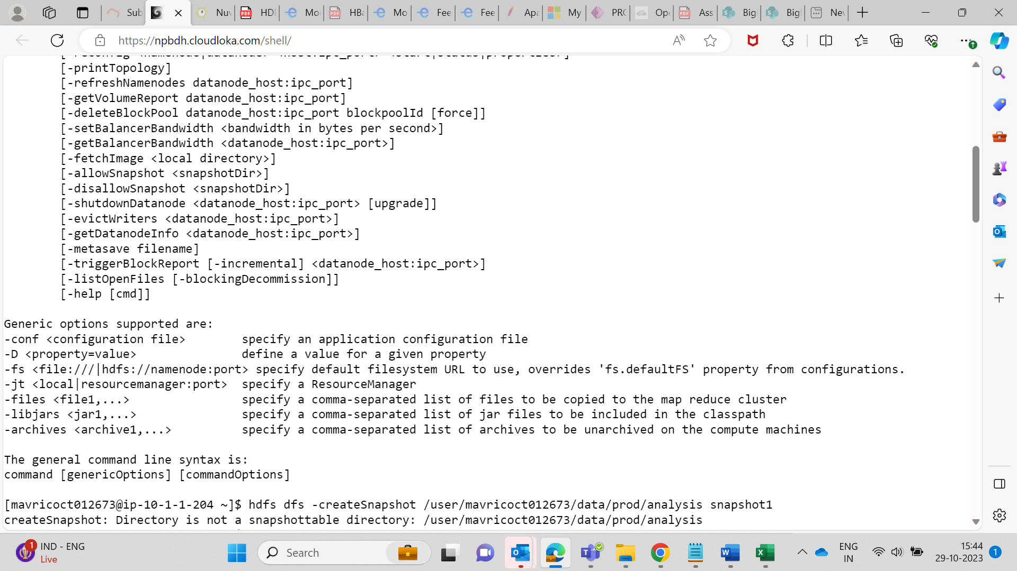

**17. Set a replication factor of 3 for all files within the file directory.**

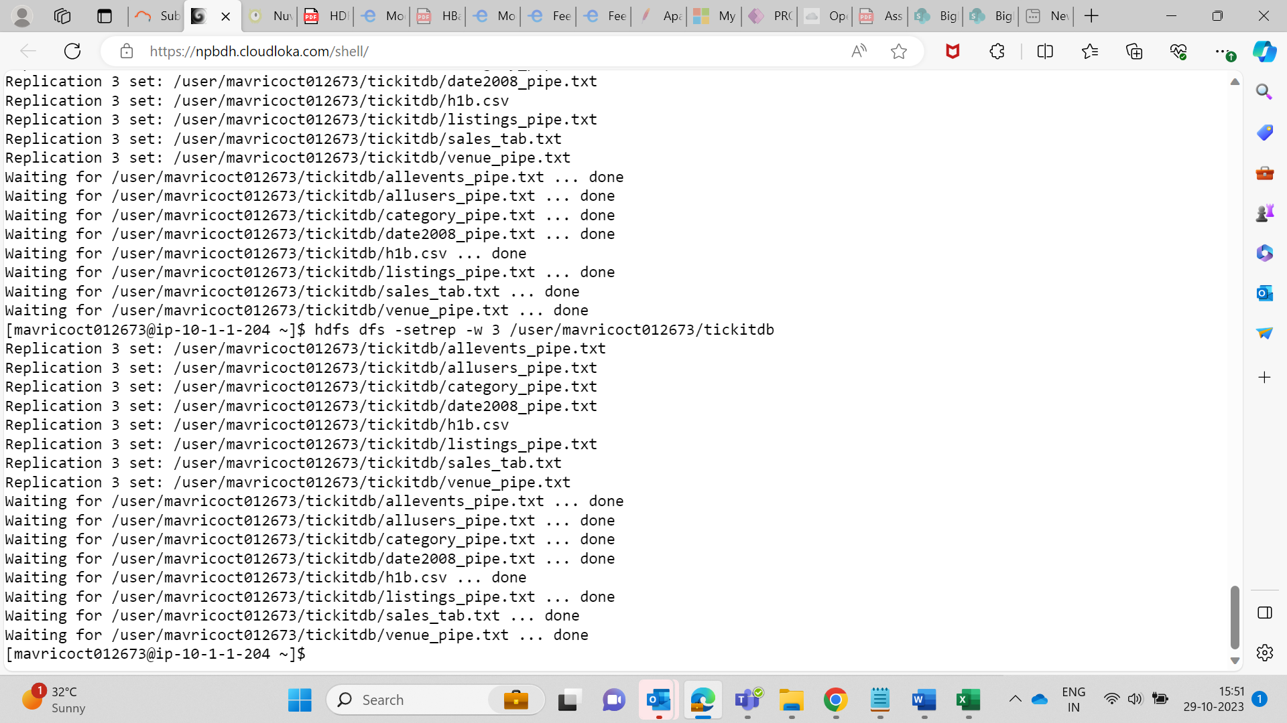

**18. Rename the 'file name' file to 'new file name' within the file directory in HDFS.**

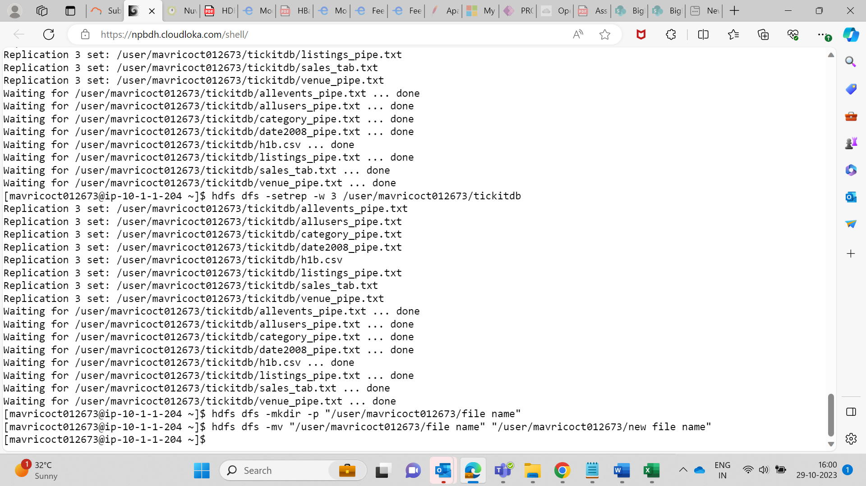

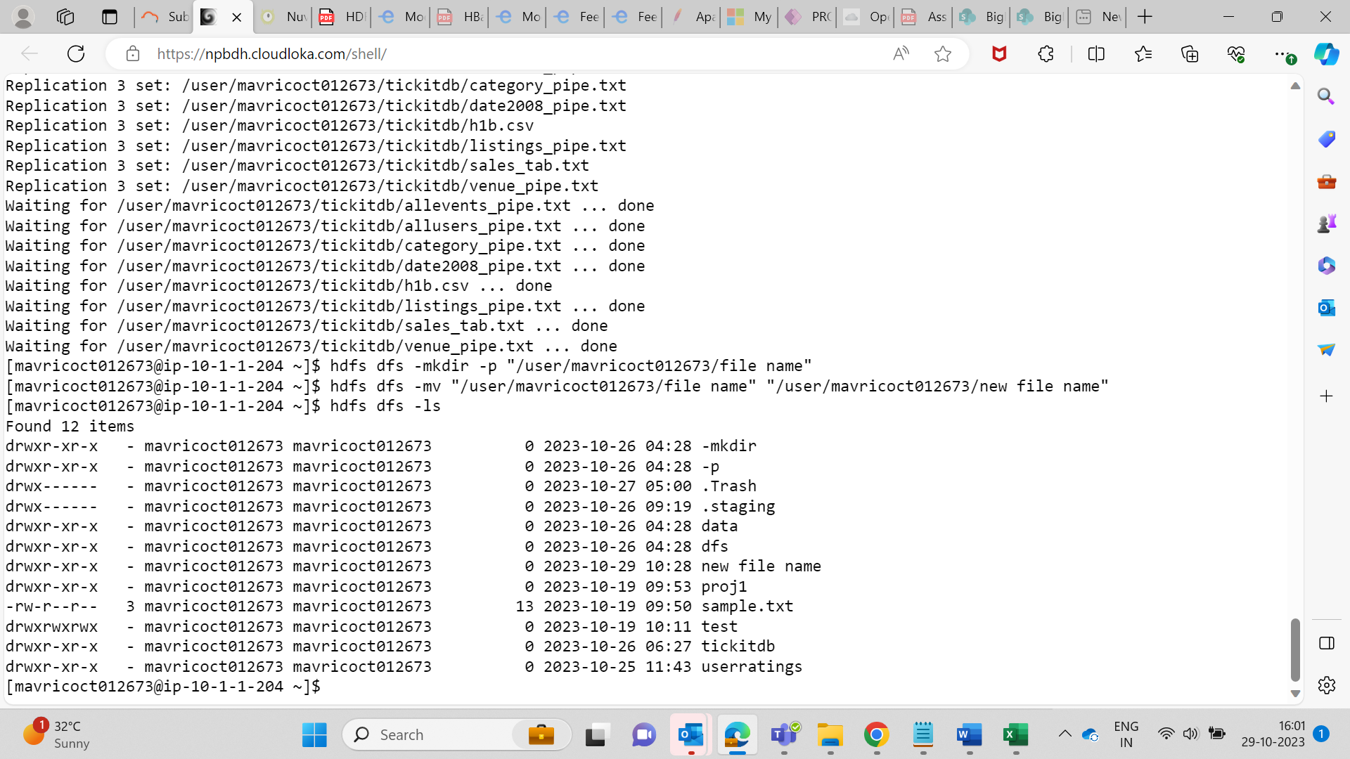

**19. List all the files and directories in the files directory in HDFS.**

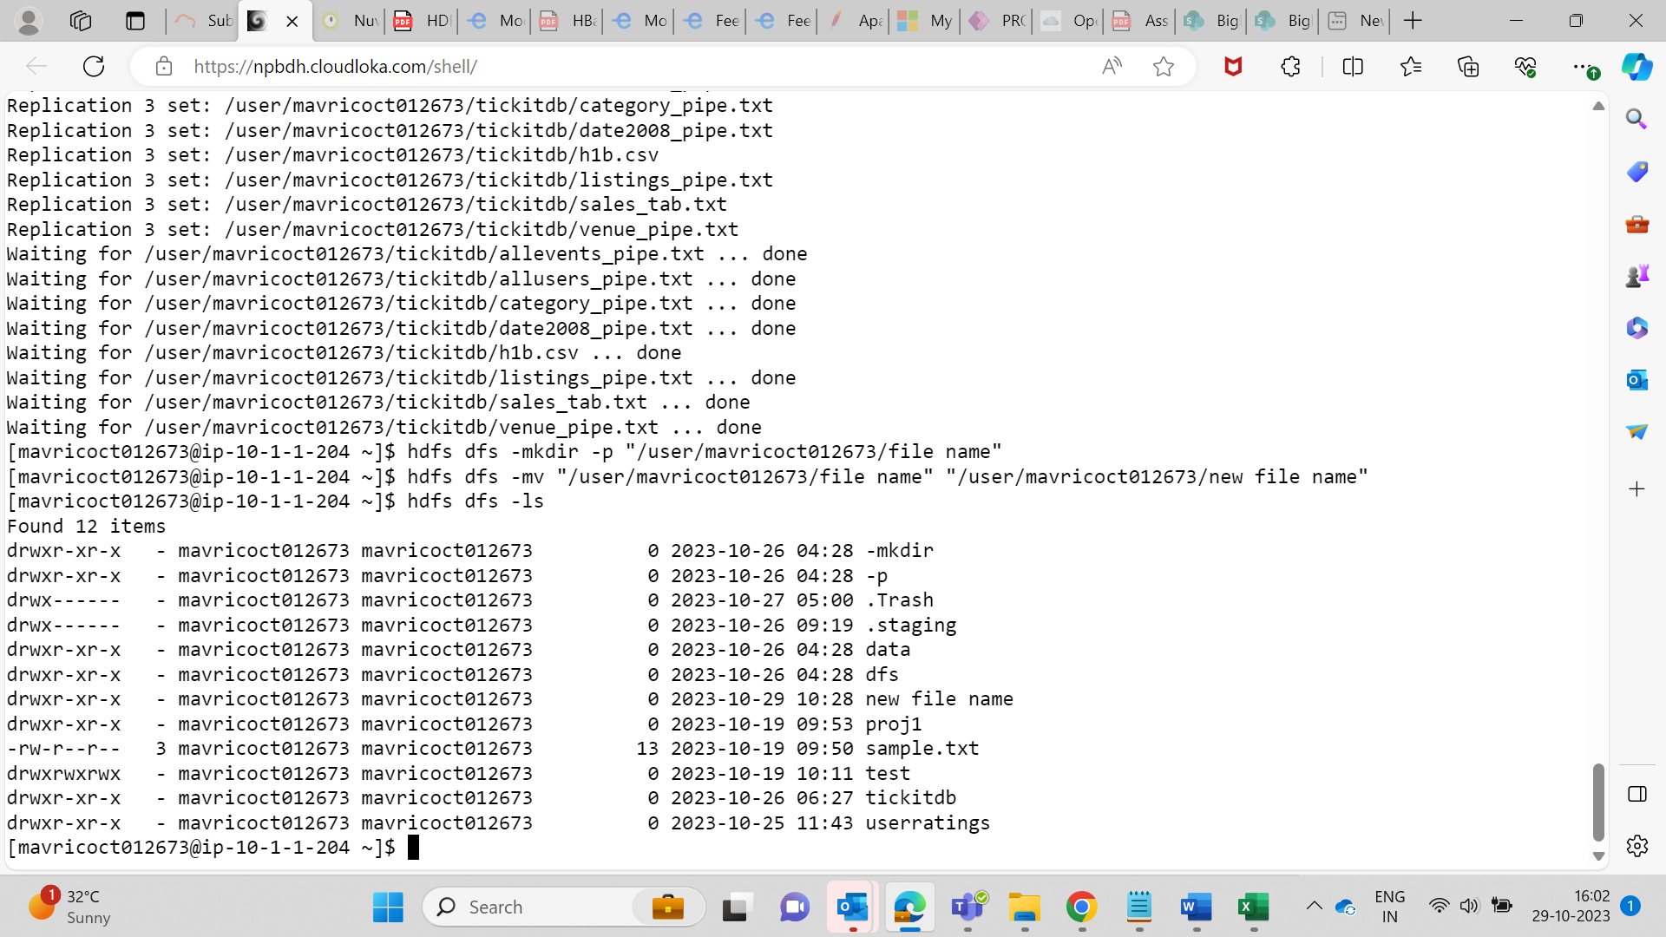

**20. Create an HDFS directory file names in your home directory and upload a local file 'test.txt' to it**

